Performance Analysis

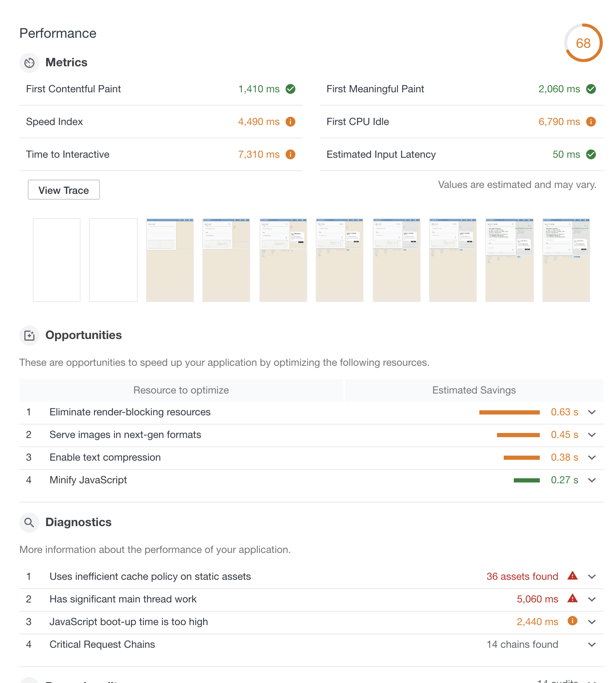
Figure 1.1 The Baseline Audit Report of the Competitor's website

I. Metrics section

The overall score is 68, means that we have lots of things to do in order to improve the performance of the website.

Time to Interactive & First CPU Idle are 7210ms and 6790ms respectively, which indicates that there is maybe unnecessary Javascript work occuring during page load.

Speed Index metric is 4490ms, which is quite high. This indicates that the content of the site need to be optimized.

Continue with the Screenshort during page load. The Ads from google is displayed before the Lists (top-right) section is displayed. This is due to the order of scripts-loading in the index.html file.

II. Opotunities section

2.1 Eliminate render-blocking resources

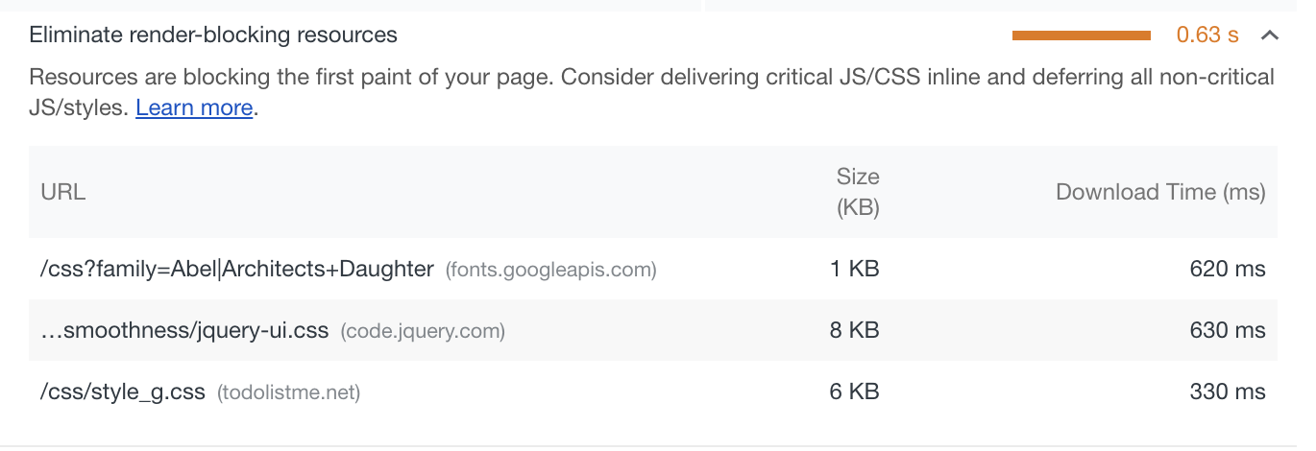
These resources are placed in the <head> tag inside index.html file, which is fine. But the dev.version jquery-ui.css is being used instead of minified version.

2.2 Serve images in next-gen formats

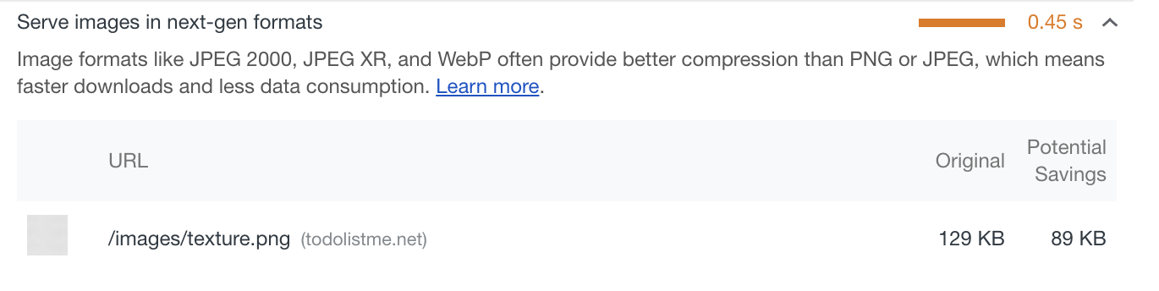
We can consider converting the image format from PNG to a more suitable format. Because the image texture.png is not an image with transparent background.

2.3 Enable text compression

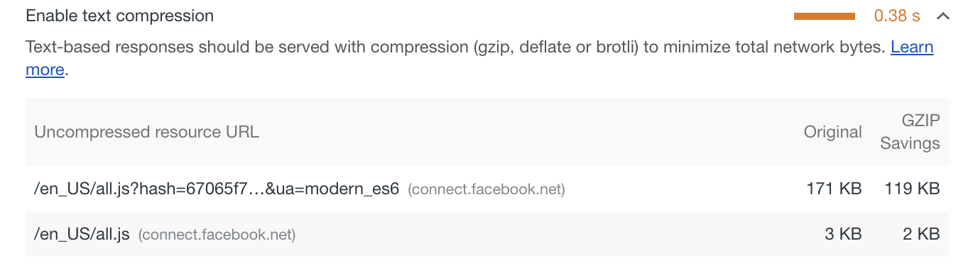
solution: by using compression middleware in the server-side, the text-based responses's size can be minimized, which can speed up the page load.

2.4 Minify the Javascript file
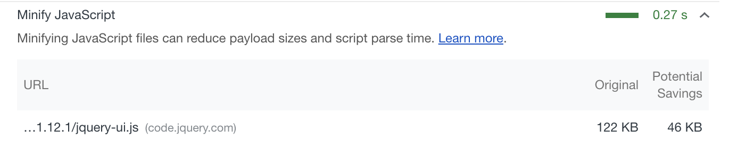
The jquery-ui.js (line 248) is not minified. Consider serving the site with a minified version can speed up the page loading.

III. Diagnostics

1. Uses inefficient cache policy on static assets.
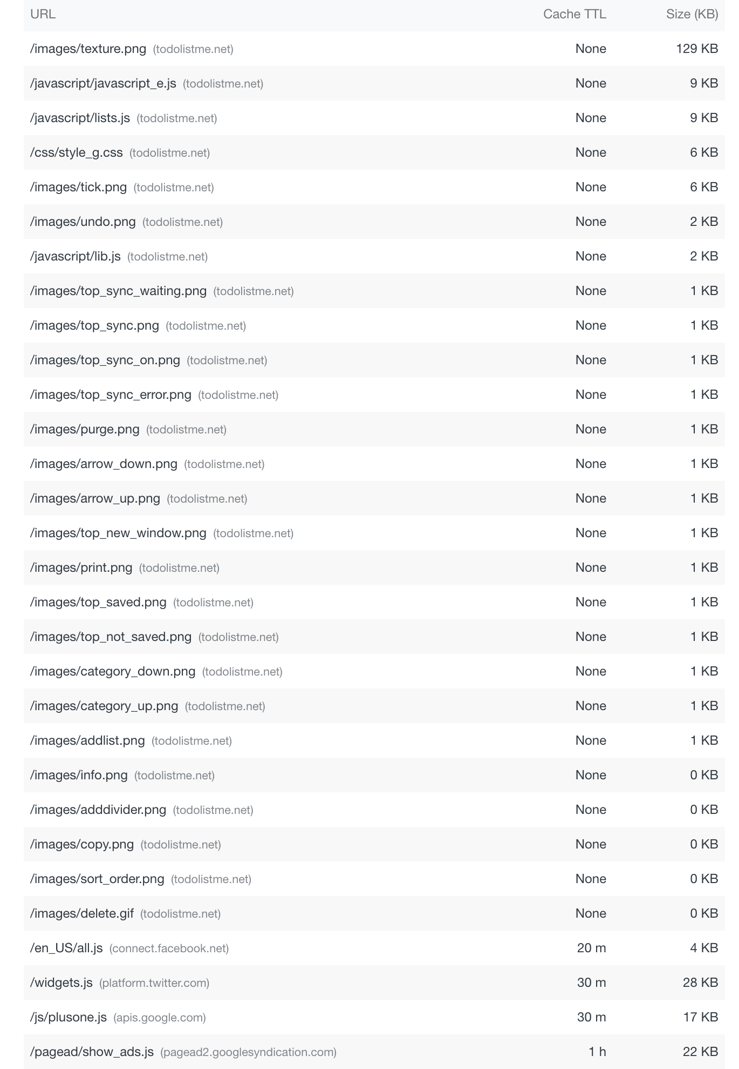
There are some static assets that wont need to be updated / changed in the next few months (libs, images, icon, logo,...). Consider enalbing / increase Cach-Control: max-age in the HTTP response header can speed up page load time on repeat visits
3.2 Significant main thread work (6270ms)

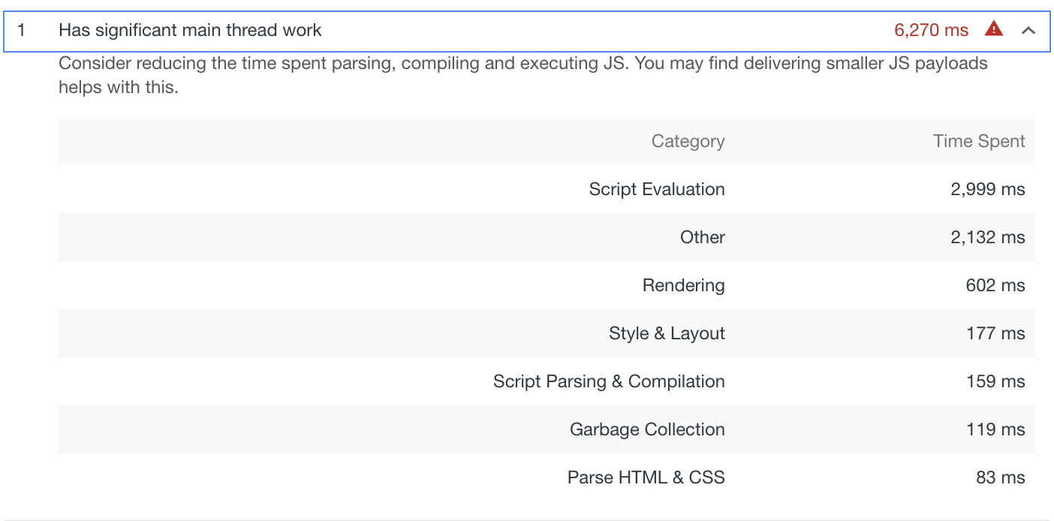
which indicates that the server has delivered a too big amount of JS.

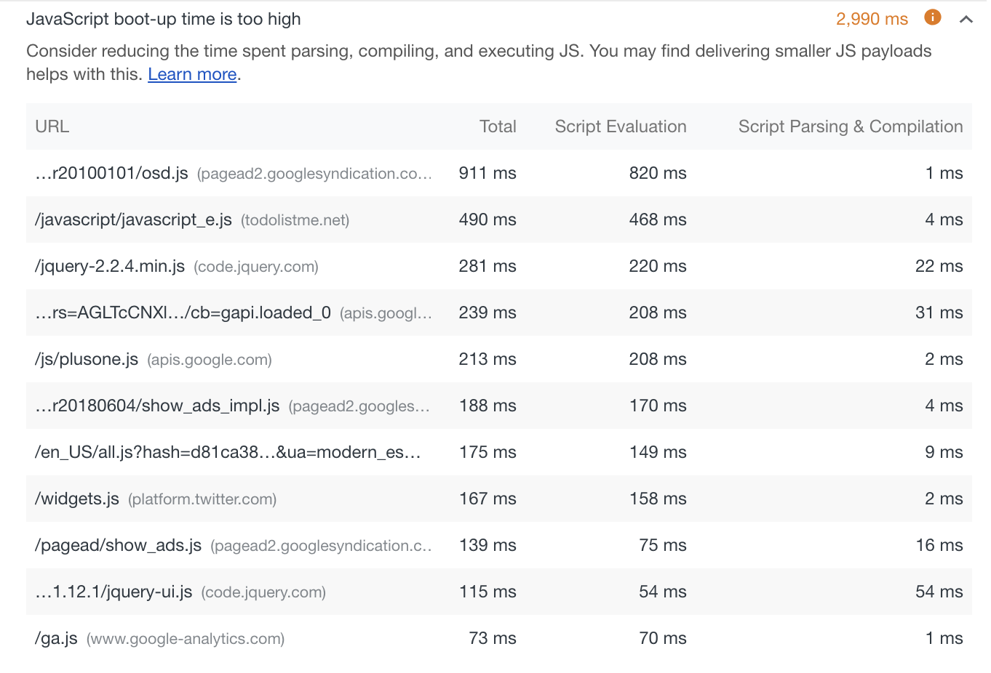
3.3 Javascript boot-up time is too high.

We can see at the first place is a JS file from google, which probaly loads Advertisements to the website. And the Script Evaluation time for this file is highest. Consider removing the script from index.html to speed up the page load.

We can open the tab Request Blocking and simulately block this JS file. Now look at the result

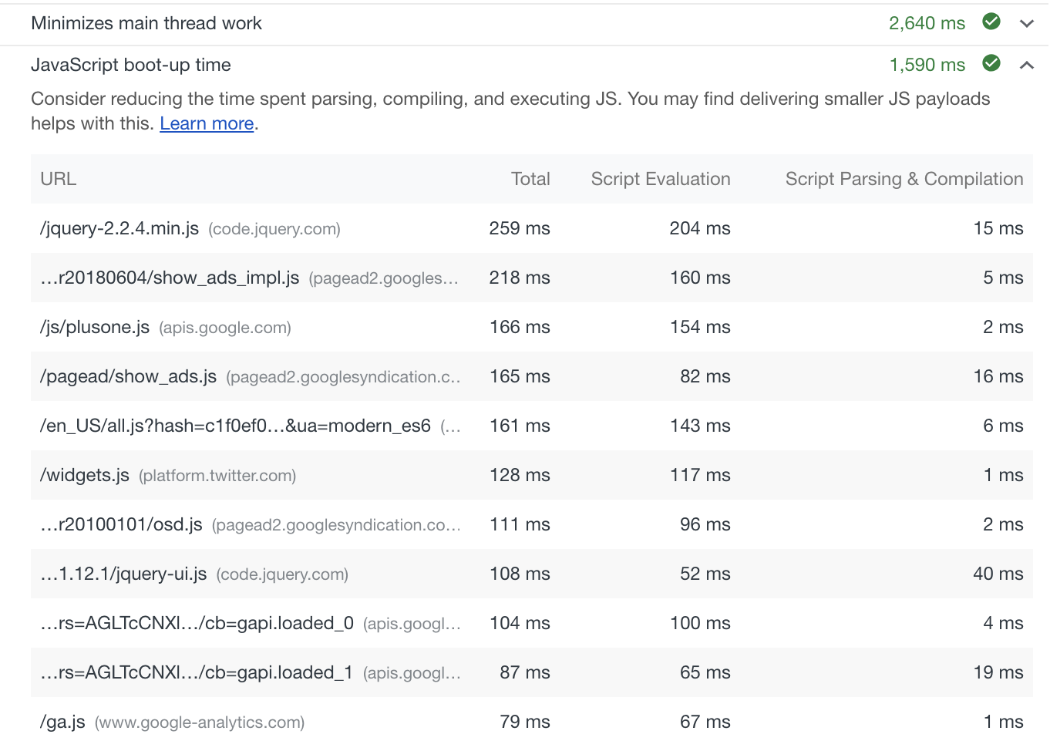
A big win!

And now look at the overall after blocking the Ads from google.
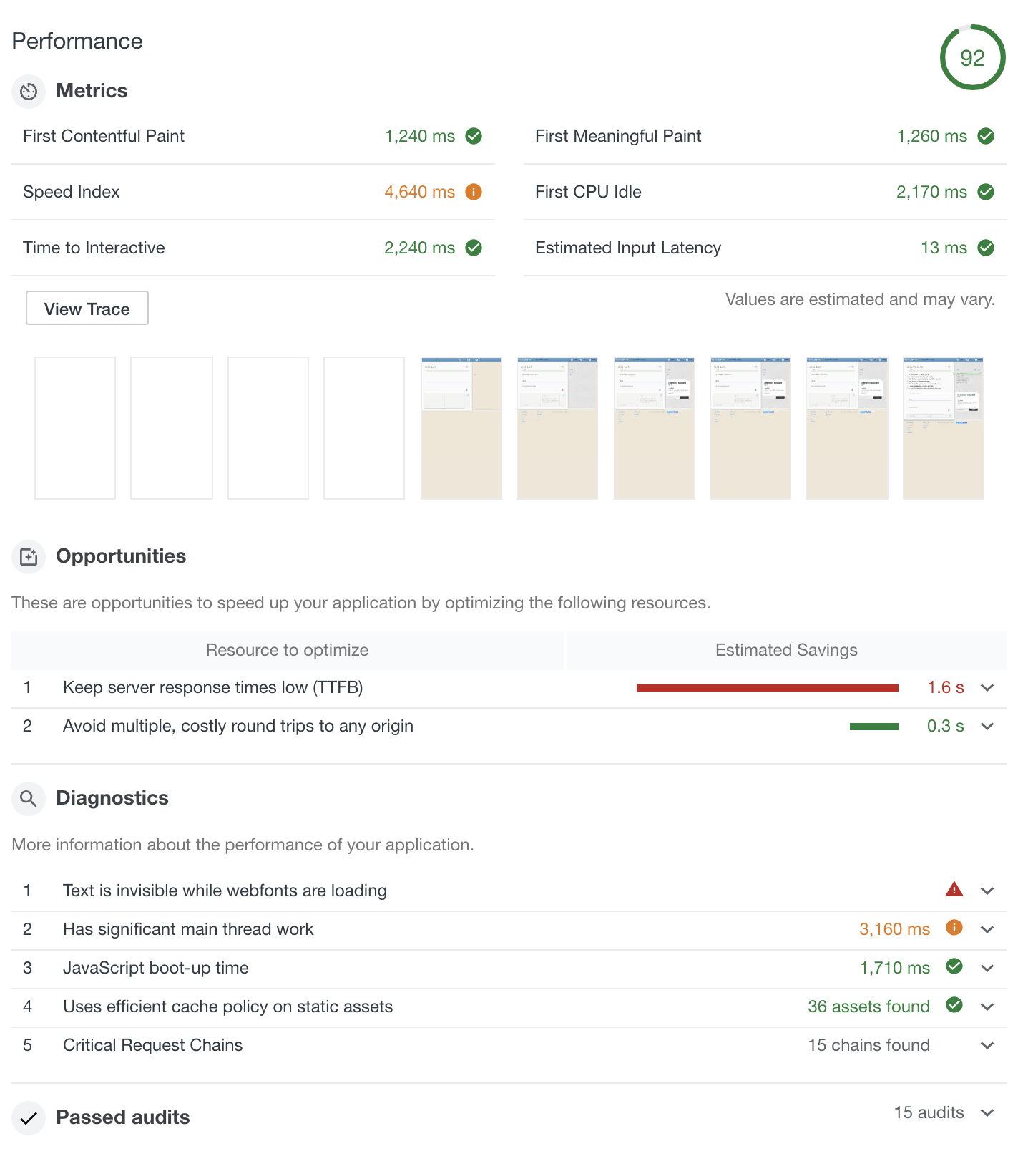
Now compare with the performance of our website.

